Lab 1 Basic HTML, CSS and JavaScript
Based on the provided example, priceList2, of dynamically creating and styling a table, create a front-end only Jokes app.
You need to create up to 10 jokes and emulate data retrieved from the backend as demonstrated in the priceList2 example.
The output should look something like the following – choose your own style:
If one joke is requested, display the setup and punchline of the joke on separate lines. E.g.

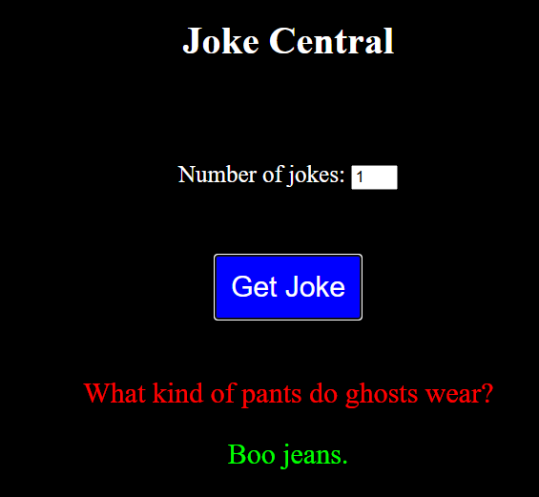

If more than one joke is requested, display them in a table. E.g.
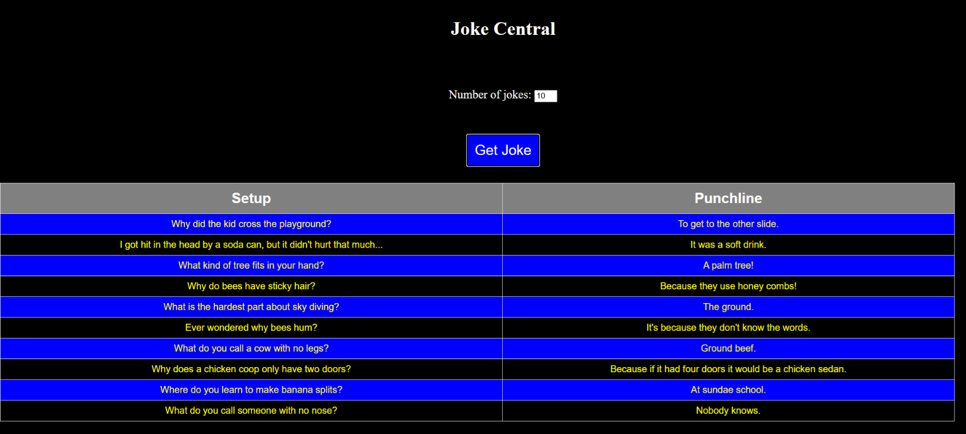

Your solution should be available to be seen on request

